Declarative Flowchart Renderer & Studio: Technical Architecture & User Manual
Document Version 1.0 | Target Environment: General Software, Firmware & Technical Engineering | Author: Systems Engineering

1. Executive Summary & Architectural Deep Dive
The Declarative Flowchart Suite is an open, standalone rendering engine and GUI workbench designed for generating clear, publication-quality software architecture state machines, hardware initialization workflows, and procedural flowcharts. It compiles structured JSON specifications—embedded within Markdown design documents or standalone .json files—into vector-quality PNG diagrams tailored for technical design documents, Word manuals, and engineering specifications.

1.1 Motivation & System Constraints
Standard technical diagramming toolchains often depend on external binary utilities such as Graphviz (dot) or heavy JavaScript runtimes (Mermaid CLI). On restricted automated build servers, air-gapped development workstations, and locked-down corporate environments, installing native C++ graph layout binaries is frequently prohibited or impractical. This flowchart renderer resolves that bottleneck by executing entirely in pure Python using Matplotlib as its single rendering backend.

1.2 The 3-Pass Layout & Measurement Engine
To ensure crisp, publication-grade output without text overflowing shape boundaries or creating awkward padding, flowchart.py implements a deterministic 3-Pass Layout Algorithm:
- Pass 1: Text Wrapping & Initial Placement (_place_text): Text strings are split across explicit newlines and dynamically wrapped according to shape constraints (22 characters per line for decision diamonds, 26 characters per line for standard rectangular boxes). An off-screen Matplotlib text element is initialized at provisional grid coordinates.
- Pass 2: Physical Pixel-to-Inch Extent Measurement (_measure): Instead of estimating character widths (which causes box under-sizing when rendering capital letters or underscores), the engine queries the true rendered bounding box in display pixels using get_window_extent(). Dividing display pixels by the active canvas DPI converts the dimensions directly into physical inches. Bounding box dimensions (_w, _h) are dynamically expanded, applying specialized padding multipliers (1.45× width padding, 1.55× height padding) to account for diamond corner geometry.
- Pass 3: Geometric Outline & Edge Construction (_draw_shape & _draw_edge): Custom vector patches (FancyBboxPatch for rounded process/terminal capsules, Polygon for decision diamonds and slanted I/O parallelograms) are drawn behind the pre-positioned text layer (z-order 2). Directed edge lines, arrows, and orthogonal side-rail connectors are layered beneath (z-order 1).

1.3 Spatial Coordinate Mechanics & Scale Invariance
A core architectural invariant of the system is that 1 data unit in Matplotlib corresponds to exactly 1 physical inch on the target rendered page. Node grid coordinates (col, row) map directly to spatial positions via pitch constants: horizontal pitch COL_W = 2.62 in and vertical pitch ROW_H = 0.84 in. Because coordinate space and measurement units are identical, shape sizing and typography remain 100% scale-stable regardless of output aspect ratio or image resolution.

1.4 Smart Edge Routing & Loop-Back Rails
The routing module (_draw_edge) evaluates relative node orientations to establish clean connections:
- Natural Facing Side Routing: Connects adjacent nodes across top, bottom, left, or right anchors based on vertical, horizontal, or diagonal grid alignment.
- Side-Rail Loop-Back Routing (route="left" | "right"): Designed for feedback and retry loops. Rather than cutting directly through intervening nodes sitting in the same column, the connector detours around the flow via a dedicated outer rail offset by 0.62 inches. Outer rail coordinates are appended to the figure extent calculation, preventing loop lines from being clipped off at canvas edges.

2. JSON Specification Language Reference
Flowchart specifications are written in declarative JSON inside Markdown ```flow code fences or standalone .json specification files.
{
"w": 5.0,
"caption": "Standard Data Processing Loop",
"nodes": [
{"id": "A", "col": 0, "row": 0, "text": "Start Task", "shape": "terminal"},
{"id": "B", "col": 0, "row": 1, "text": "Read Input Stream", "shape": "io"},
{"id": "C", "col": 0, "row": 2, "text": "Data Valid?", "shape": "decision"}
],
"edges": [
["A", "B"],
["B", "C"],
["C", "B", "retry", "right"]
]
}

2.1 Supported Node Shapes
Shape Key | Visual Geometry | Fill / Border Palette | Typical Application Usage
terminal | Rounded Pill (0.30 rounding) | #D6E4D2 / #4A7A3C (Soft Green) | Start, Stop, Task Entry / Exit Points, Interrupt Entry
box | Standard Rectangle (0.04 rounding) | #E8EEF7 / #2F5597 (Ice Blue) | Standard Processing Task, System Action, Function Call
decision | Diamond Polygon | #FCF0D8 / #B8860B (Pale Gold) | Conditional Branching, Status Flag Test, Threshold Check
io | Parallelogram (0.16 horizontal skew) | #EDE4F3 / #6B4A8F (Soft Lavender) | Data I/O Operations, Peripheral Communication, File Input
note | Dashed Border Rectangle | #F5F5F5 / #888888 (Light Gray) | Annotations, Error Handling Steps, Explanatory Comments

2.2 Edge Definition & Routing Format
Edges connect nodes using an array structure consisting of 2 to 4 fields:
["SOURCE_ID", "TARGET_ID", "LABEL", "ROUTE"]
- Source ID (Field 1): Identifier string of origin node.
- Target ID (Field 2): Identifier string of destination node.
- Label (Field 3, Optional): Text label displayed centered along the connection path.
- Route (Field 4, Optional): Set to "left" or "right" to force side-rail loop routing around intermediate nodes.

3. Flowchart Studio Desktop Application Guide
Flowchart Studio (flowchart_studio.py) provides an interactive desktop editing environment built with Tkinter and Pillow. It features real-time preview rendering, eliminating the manual steps of executing document build scripts.

3.1 Application Interface & UI Layout
Below is the structural visual layout of the Flowchart Studio desktop interface:
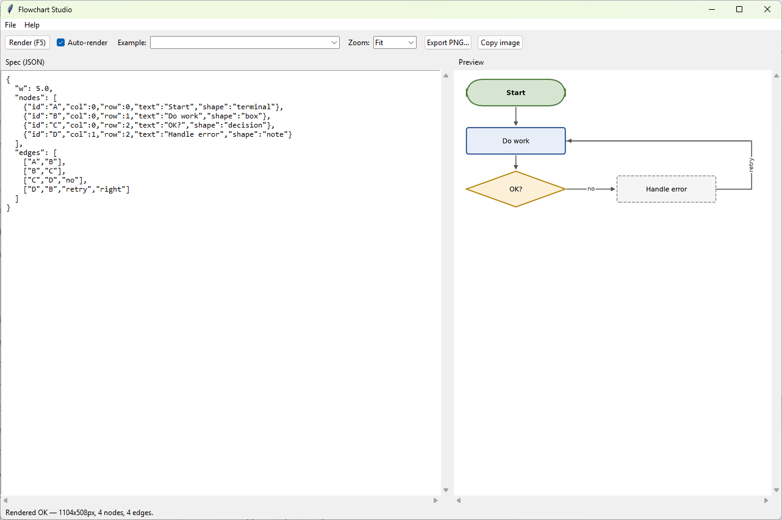

3.2 Key Application Capabilities
- Debounced Real-Time Auto-Render: Automatically re-renders the visual canvas 500ms after text modification in the JSON editor panel.
- Markdown Example Harvester: Automatically scans _src/*.md documentation files on startup, extracts all ```flow JSON code blocks, and populates the example selection dropdown.
- Native Clipboard Integration: Copies rendered images directly to the system clipboard in Device Independent Bitmap (CF_DIB) format using pywin32, permitting direct Ctrl+V pasting into Word, Teams, or Outlook.
- Background Launcher: Includes Flowchart Studio.bat utilizing pythonw to run silently in the background without spawning terminal windows.

3.3 Keyboard Shortcuts & Command Reference
Shortcut | Action | Description
F5 / Ctrl + Enter | Render Now | Forces immediate re-parsing of JSON spec and canvas re-draw.
Ctrl + O | Open Spec | Opens standard file dialog to load an external .json flowchart specification.
Ctrl + S | Save Spec | Saves active editor text contents to disk as a JSON file.
Ctrl + Shift + S | Export PNG | Saves rendered high-resolution figure PNG to disk.
Ctrl + C (Canvas Focused) | Copy Image | Copies rendered diagram image directly to the system clipboard.

4. Hands-On Specification Examples & Rendered Flow Maps

4.1 Tutorial 1: General Process Flow with Side-Rail Retry Loop
This example demonstrates a standard sequential process with conditional validation and a side-routed retry path.
{
"w": 5.0,
"nodes": [
{"id": "A", "col": 0, "row": 0, "text": "Start Process", "shape": "terminal"},
{"id": "B", "col": 0, "row": 1, "text": "Initialize Hardware", "shape": "box"},
{"id": "C", "col": 0, "row": 2, "text": "Read Sensor Data", "shape": "io"},
{"id": "D", "col": 0, "row": 3, "text": "Data Valid?", "shape": "decision"},
{"id": "E", "col": 1, "row": 3, "text": "Log Error & Retry", "shape": "note"},
{"id": "F", "col": 0, "row": 4, "text": "End / Transmit", "shape": "terminal"}
],
"edges": [
["A", "B"],
["B", "C"],
["C", "D"],
["D", "E", "no"],
["E", "C", "retry", "right"],
["D", "F", "yes"]
]
}
Rendered Flow Architecture Structure:
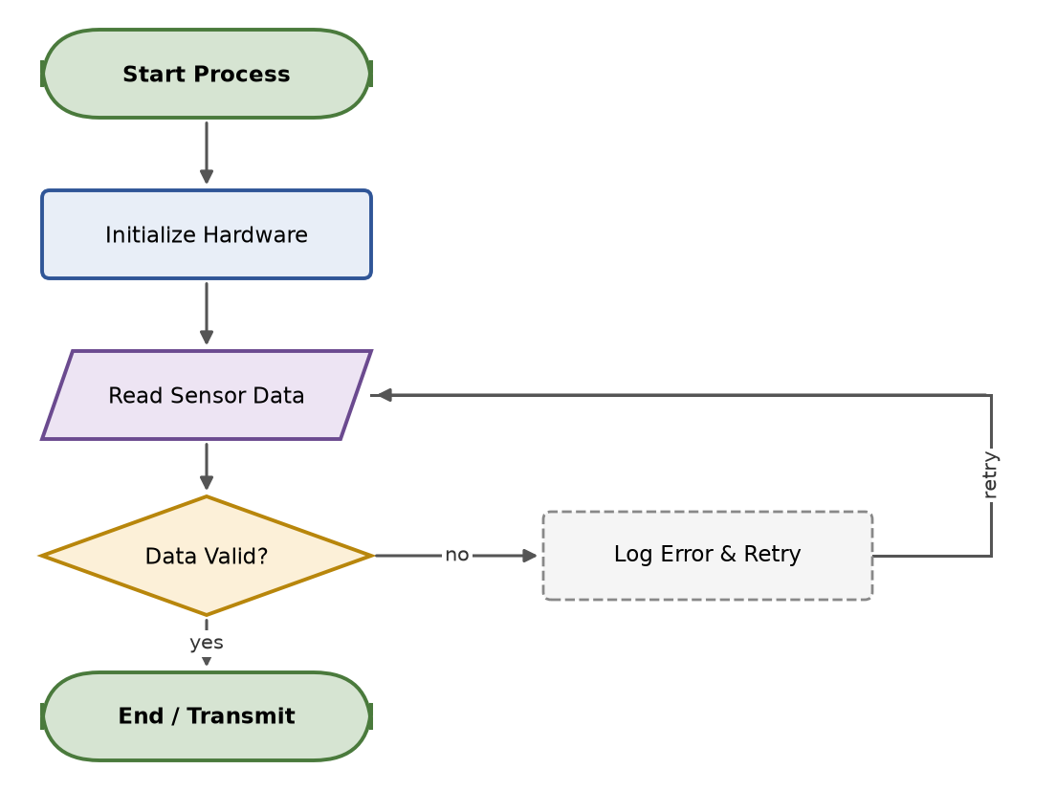
4.2 Tutorial 2: State Machine / Task Loop Workflow
This example illustrates a multi-stage task loop containing conditional alarm branching and a left-side feedback rail.
{
"w": 7.0,
"nodes": [
{"id": "INIT", "col": 0, "row": 0, "text": "System Reset / Boot", "shape": "terminal"},
{"id": "ADC_CFG", "col": 0, "row": 1, "text": "Configure ADC & DMA Buffers", "shape": "box"},
{"id": "WAIT_TRIG", "col": 0, "row": 2, "text": "Wait for Timer Trigger", "shape": "box"},
{"id": "READ_ADC", "col": 0, "row": 3, "text": "Read Sample Vector", "shape": "io"},
{"id": "CHK_THRES", "col": 0, "row": 4, "text": "Exceeds Threshold?", "shape": "decision"},
{"id": "ALARM", "col": 1, "row": 4, "text": "Raise Hardware Alarm Interrupt", "shape": "box"},
{"id": "LOG_DATA", "col": 0, "row": 5, "text": "Write to Ring Buffer", "shape": "box"},
{"id": "END", "col": 0, "row": 6, "text": "Task Sleep / Idle", "shape": "terminal"}
],
"edges": [
["INIT", "ADC_CFG"],
["ADC_CFG", "WAIT_TRIG"],
["WAIT_TRIG", "READ_ADC"],
["READ_ADC", "CHK_THRES"],
["CHK_THRES", "ALARM", "yes"],
["CHK_THRES", "LOG_DATA", "no"],
["ALARM", "LOG_DATA"],
["LOG_DATA", "END"],
["END", "WAIT_TRIG", "loop", "left"]
]
}

Rendered State Machine Architecture Structure: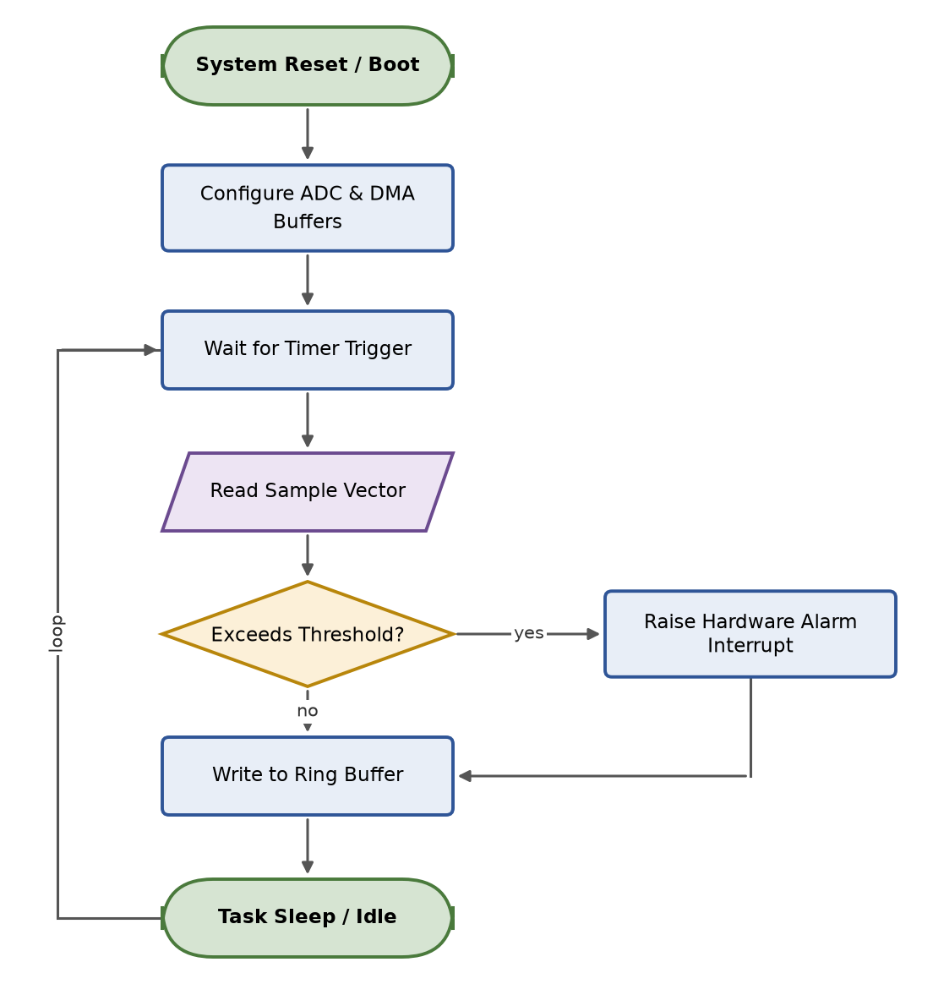

5. Best Practices & Customization Guide

5.1 Layout Rules & Edge Avoidance Strategies
- Grid Alignment & Edge Overlaps: Standard vertical connector arrows skip directly from source to target row. If another node sits on an intermediate row in the same column, the connector will draw across that node. Solution: Shift target nodes onto an adjacent vacant column or route connectors around using route="left" or route="right".
- Disambiguating Dual Parallel Feedback Rails: When two retry or feedback paths exit from the same state machine block, assign one path route="left" and the other path route="right" to prevent rail overlapping.
- Manual Line Wrapping: Use explicit \n line breaks inside JSON text strings when precise control over box aspect ratios is required.

5.2 Customizing Color Palettes
To adjust default fill and edge styling, modify the STYLE dictionary definition at the top of flowchart.py:
STYLE = {
"box": {"fc": "#E8EEF7", "ec": "#2F5597", "lw": 1.4},
"terminal": {"fc": "#D6E4D2", "ec": "#4A7A3C", "lw": 1.4},
"decision": {"fc": "#FCF0D8", "ec": "#B8860B", "lw": 1.4},
"io": {"fc": "#EDE4F3", "ec": "#6B4A8F", "lw": 1.4},
"note": {"fc": "#F5F5F5", "ec": "#888888", "lw": 1.0},
}

